

# 

### Semester Two Examination, 2017

### Question/Answer booklet

# MATHEMATICS

**SOLUTIONS**

**SPECIALIST**

**UNITS 1 AND 2**

## Section Two:

## Calculator-assumed

|  |  |  |  |  |  |  |  |  |  |  |
| --- | --- | --- | --- | --- | --- | --- | --- | --- | --- | --- |
| Student Number: In figures |  |  |  |  |  |  |  |  |  |  |

In words

Your name

## Time allowed for this section

Reading time before commencing work: ten minutes

Working time: one hundred minutes

## Materials required/recommended for this section

***To be provided by the supervisor***

This Question/Answer booklet

Formula sheet (retained from Section One)

***To be provided by the candidate***

Standard items: pens (blue/black preferred), pencils (including coloured), sharpener, correction fluid/tape, eraser, ruler, highlighters

Special items: drawing instruments, templates, notes on two unfolded sheets of A4 paper, and up to three calculators approved for use in this examination

## Important note to candidates

No other items may be taken into the examination room. It is **your** responsibility to ensure that you do not have any unauthorised material. If you have any unauthorised material with you, hand it to the supervisor **before** reading any further.

## Structure of this paper

|  |  |  |  |  |  |
| --- | --- | --- | --- | --- | --- |
| Section | Number of questions available | Number of questions to be answered | Working  time (minutes) | Marks available | Percentage of examination |
| Section One:  Calculator-free | 8 | 8 | 50 | 52 | 35 |
| Section Two:  Calculator-assumed | 13 | 13 | 100 | 98 | 65 |
|  | | |  | **Total** | 100 |

## Instructions to candidates

1. The rules for the conduct of examinations are detailed in the school handbook. Sitting this examination implies that you agree to abide by these rules.

2. Write your answers in this Question/Answer booklet.

3. You must be careful to confine your response to the specific question asked and to follow any instructions that are specified to a particular question.

4. Additional working space pages at the end of this Question/Answer booklet are for planning or continuing an answer. If you use these pages, indicate at the original answer, the page number it is planned/continued on and write the question number being planned/continued on the additional working space page.

5. Show all your working clearly. Your working should be in sufficient detail to allow your answers to be checked readily and for marks to be awarded for reasoning. Incorrect answers given without supporting reasoning cannot be allocated any marks. For any question or part question worth more than two marks, valid working or justification is required to receive full marks. If you repeat any question, ensure that you cancel the answer you do not wish to have marked.

6. It is recommended that you do not use pencil, except in diagrams.

7. The Formula sheet is not to be handed in with your Question/Answer booklet.

Section Two: Calculator-assumed 65% (98 Marks)

This section has**thirteen (****13)** questions. Answer **all** questions. Write your answers in the spaces provided.

Working time: 100 minutes.

Question 9 (6 marks)

An exam has two parts, $I$ and $II$, containing 15 and 8 questions respectively.

Determine the number of different combinations of questions a candidate could choose if they must answer

(a) 5 questions from part $I$ and 4 questions from part $II$. (2 marks)

|  |
| --- |
| **Solution** |
| $$\left(\begin{matrix}15 \\ 5\end{matrix}\right)\left(\begin{matrix}8 \\ 4\end{matrix}\right)=3003×70 \\ =210 210 \text{ways}$$ |
| **Specific behaviours** |
| ✓ uses multiplication of combinations  ✓ correct number |

(b) 3 questions, all chosen from the same part. (2 marks)

|  |
| --- |
| **Solution** |
| $$\left(\begin{matrix}15 \\ 0\end{matrix}\right)\left(\begin{matrix}8 \\ 3\end{matrix}\right)+\left(\begin{matrix}15 \\ 3\end{matrix}\right)\left(\begin{matrix}8 \\ 0\end{matrix}\right)=56+455 \\ =511 \text{ways}$$ |
| **Specific behaviours** |
| ✓ uses addition of combinations  ✓ correct number |

(c) 3 questions, with at least one question from each part. (2 marks)

|  |
| --- |
| **Solution** |
| $$\left(\begin{matrix}23 \\ 3\end{matrix}\right)=1771$$ $$1771-511=1 260 \text{ways}$$ |
| **Specific behaviours** |
| ✓ calculates total ways, no restriction  ✓ subtracts answer from (b) |

Question 10 (6 marks)

(a) The point $P(4, -7)$ is translated by the column vectors $\left[\begin{matrix}x \\ y\end{matrix}\right]$ and $\left[\begin{matrix}-8 \\ 11\end{matrix}\right]$ to $P'(17, -13)$. Determine the values of the constants $x$ and $y$. (2 marks)

|  |
| --- |
| **Solution** |
| $$\left[\begin{matrix}4 \\ -7\end{matrix}\right]+\left[\begin{matrix}x \\ y\end{matrix}\right]+\left[\begin{matrix}-8 \\ 11\end{matrix}\right]=\left[\begin{matrix}17 \\ -13\end{matrix}\right]$$ $$\left[\begin{matrix}x \\ y\end{matrix}\right]=\left[\begin{matrix}17 \\ -13\end{matrix}\right]-\left[\begin{matrix}4 \\ -7\end{matrix}\right]-\left[\begin{matrix}-8 \\ 11\end{matrix}\right]$$ $$\left[\begin{matrix}x \\ y\end{matrix}\right]=\left[\begin{matrix}21 \\ -17\end{matrix}\right]$$ |
| **Specific behaviours** |
| ✓ value of  ✓ value of $y$ |

(b) Determine the single matrix that represents, in order, the composition of a reflection in the line $y=\sqrt{3}x$ followed by a rotation of $180°$ about the origin. Express matrix coefficients in exact form. (4 marks)

|  |
| --- |
| **Solution** |
| $$\tan{θ}=\sqrt{3}⇒θ=60°$$ $$\left[\begin{matrix}-1 & 0 \\ 0 & -1\end{matrix}\right]×\left[\begin{matrix}\cos{120} & \sin{120} \\ \sin{120} & -\cos{120}\end{matrix}\right]=\left[\begin{matrix}\frac{1}{2} & -\frac{\sqrt{3}}{2} \\ -\frac{\sqrt{3}}{2} & -\frac{1}{2}\end{matrix}\right]$$ |
| **Specific behaviours** |
| ✓ matrix for reflection  ✓ matrix for rotation  ✓ multiplies in correct order  ✓ correct matrix |

Question 11 (6 marks)

(a) A circle property says that if chords of a circle are of equal length then they subtend equal angles at the centre.

(i) Write the inverse of this statement. (1 mark)

|  |
| --- |
| **Solution** |
| If chords of a circle are of not of equal length then they do not subtend equal angles at the centre. |
| **Specific behaviours** |
| ✓ writes converse |

(ii) Draw a diagram to illustrate the inverse statement and state whether it is true.

(2 marks)

|  |
| --- |
| **Solution** |
| Inverse is true. |
| **Specific behaviours** |
| ✓ diagram  ✓ states inverse true |

(b) The diagram below shows four points $A$, $B$, $C$ and $D$ lying on the circumference of a circle. The line $PQ$ is a tangent to the circle at $C$, $∠PCD=26°$, $∠QCB=37°$ and $∠ADB=65°$.

Determine the size of angles $x$, $y$ and $z$. (3 marks)

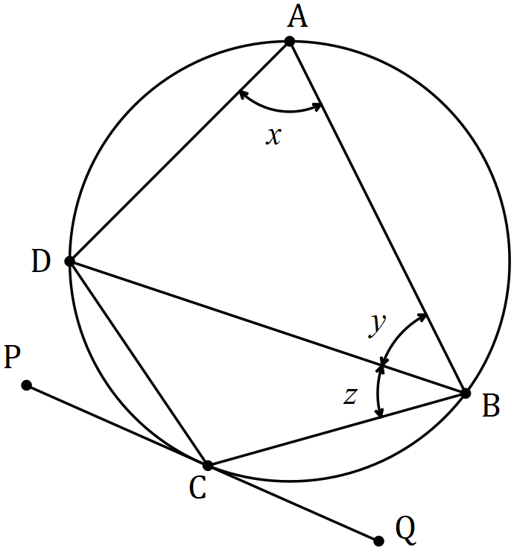

|  |
| --- |
| **Solution** |
| $$x=180-\left(180-26-37\right)=63°$$ $$y=180-63-65=52°$$ $$z=∠PCD=26°$$ |
| **Specific behaviours** |
| ✓✓✓ each angle |

Question 12 (9 marks)

(a) If $p=13i-11j$ and $q=15i+4j$ determine

(i) the angle between the directions of $p$ and $q$, to the nearest tenth of a degree.

(2 marks)

|  |
| --- |
| **Solution** |
| $$\text{Using CAS angle is} 55.168≈55.2° \text{(1dp)}$$ |
| **Specific behaviours** |
| ✓ states angle  ✓ rounds correctly |

(ii) the scalar projection of $p$ on $q$. (2 marks)

|  |
| --- |
| **Solution** |
| $$\sqrt{{13}^{2}+{(-11)}^{2}}×\cos\left(55.168\right)$$ $$≈9.73$$ Exact: $\frac{151\sqrt{241}}{241}$ |
| **Specific behaviours** |
| ✓ expression for projection  ✓ states value |

(b) The vector $45i-4aj$ has a magnitude of $53$ and is perpendicular to the vector $3i-5bj$. Determine the values of the constants a and b, where $a>b$. (5 marks)

|  |
| --- |
| **Solution** |
| $${45}^{2}+{(-4a)}^{2}={53}^{2}$$ $$a=±7$$ $$\left(45\right)\left(3\right)+(-4a)(-5b)=0$$ $$135+20(±7)b=0$$ $$b=∓\frac{27}{28}$$ $$a=7, b=-\frac{27}{28}$$ |
| **Specific behaviours** |
| ✓ uses magnitude to form equation  ✓ calculate values of a  ✓ uses dot product to form equation  ✓ calculate values of b  ✓ chooses correct pairing |

Question 13 (7 marks)

(a) Point $R$ lies on the circumference of a circle with diameter $PQ=51$ cm, so that $PR=4RQ$. Determine the exact length $RQ$. (3 marks)

|  |
| --- |
| **Solution** |
| $$\text{Let} RQ=x, \text{then} x^{2}+(4{x)}^{2}={51}^{2}$$ $$x=3\sqrt{17} \text{cm}$$ |
| **Specific behaviours** |
| ✓ diagram  ✓ uses Pythagoras' Theorem  ✓ states length |

(b) Use a vector method to prove that the angle in a semi-circle is a right-angle. (4 marks)

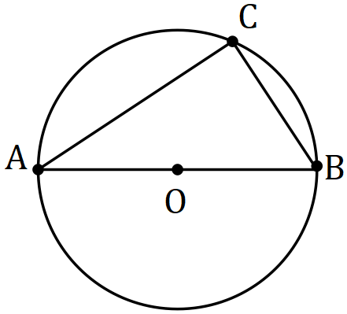

Let $\vec{OC}=c$ and $\vec{OB}=b$.

|  |
| --- |
| **Solution** |
|  |
| **Specific behaviours** |
| ✓ vectors for ,  ✓ forms scalar product  ✓ simplifies scalar product, with reasons  ✓ concludes angle is right |

Question 14 (6 marks)

(a) Prove that $\sin{3A}=3\sin{A}-4\sin^{3}{A}$. (4 marks)

|  |
| --- |
| **Solution** |
| $$LHS=\sin{3A} \\ =\sin\left(A+2A\right) \\ =\sin{A}\cos{2A}+\cos{A}\sin{2A} \\ =\sin{A}\left(1-2\sin^{2}{A}\right)+\cos{A}\left(2\sin{A}\cos{A}\right) \\ =\sin{A}-2\sin^{3}{A}+2sin{A}\left(1-\sin^{2}{A}\right) \\ =3\sin{A}-4\sin^{3}{A} \\ =RHS$$ |
| **Specific behaviours** |
| ✓ expands sum of A and 2A  ✓ uses double angle identity for cos2A  ✓ uses double angle identity for sin2A  ✓ expands and simplifies |

(b) Hence, or otherwise, solve $3\sin{A}-4\sin^{3}{A}=\frac{1}{2}, 0≤A≤\frac{π}{3}$. (2 marks)

|  |
| --- |
| **Solution** |
| $$\sin{3A=\frac{1}{2}} \\ 3A=\frac{π}{6},\frac{5π}{6} \\ A=\frac{π}{18},\frac{5π}{18}$$ |
| **Specific behaviours** |
| ✓ one correct solution  ✓ all solutions within required domain |

Question 15 (8 marks)

In the diagram below, forces $F_{1}$ and $F_{2}$ act on a body at the origin.

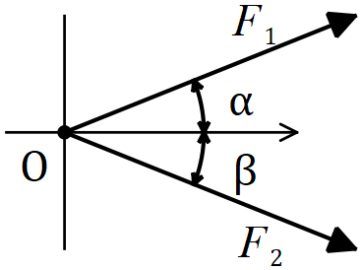

(a) If $F_{1}=85 N$, $F_{2}=105 N$, $α=21°$ and $β=35°$, determine the magnitude of the resultant force and the angle it makes with the positive $x$ axis. (5 marks)

|  |
| --- |
| **Solution** |
| $$F_{R}=\sqrt{{85}^{2}+{105}^{2}-2\left(85\right)\left(105\right)\cos{124}} \\ F_{R}=168 N$$ $$\frac{\sin{θ}}{105}=\frac{\sin{124}}{168} \\ θ=31.2°$$ $$ϕ=21°-31.2°=-10.2°$$ |
| **Specific behaviours** |
| ✓ sketch with forces nose to tail  ✓ uses cosine rule for magnitude  ✓ states magnitude  ✓ uses sine rule for angle  ✓ states angle with $x$ axis |

(b) If $F_{1}=145 N$ and $F_{2}=180 N$, determine the angles $α$ and $β$ so that the resultant force is directed along the positive $x$ axis and has a magnitude of $310 N$. (3 marks)

|  |
| --- |
| **Solution** |
| $$α=\cos^{-1}\left(\frac{{145}^{2}+{310}^{2}-{180}^{2}}{2\left(145\right)\left(310\right)}\right) \\ α=19.5°$$ $$β=\cos^{-1}\left(\frac{{180}^{2}+{310}^{2}-{145}^{2}}{2\left(180\right)\left(310\right)}\right) \\ β=15.6°$$ |
| **Specific behaviours** |
| ✓ sketch with resultant on $x$ axis  ✓ uses cosine rule for angle  ✓ uses sine or cosine rule for second angle |

Question 16 (10 marks)

(a) The graph of $y=\sin\left(a\left(x-b\right)\right)+c$ is shown below for $-π≤x≤π$.

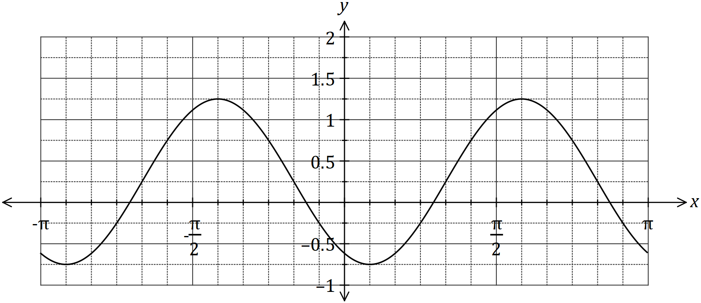

Determine the value of the positive constants $a$, $b$ and $c$. (3 marks)

|  |
| --- |
| **Solution** |
| $$a=2, b=\frac{π}{3}, c=\frac{1}{4}$$ |
| **Specific behaviours** |
| ✓ value of , ✓ value of b, ✓ value of $c$ |

(b) On the axes below, sketch the graph of $y=3\sec\left(x-\frac{π}{2}\right)$, $0≤x≤2π$. (3 marks)

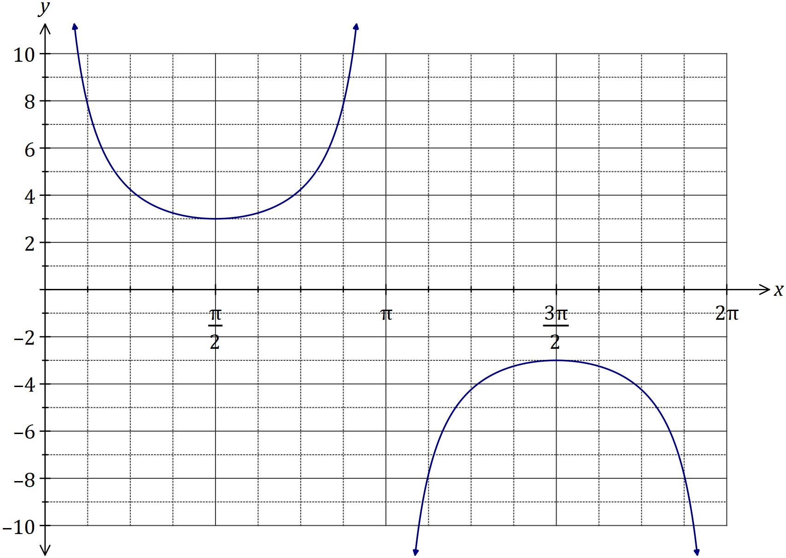

|  |
| --- |
| **Solution** |
| See graph |
| **Specific behaviours** |
| ✓ asymptotic behaviour  ✓ locations of max/min  ✓ smooth curve |

(c) The displacement, $x$ cm, of a particle from a fixed point $O$ varies with time, $t$ seconds, according to the model $x=2\sin{(4πt)}+3\cos\left(4πt\right), t≥0$. Determine

(i) the initial displacement of the particle from $O$. (1 mark)

|  |
| --- |
| **Solution** |
| $$x=3$$ |
| **Specific behaviours** |
| ✓ correct value |

(ii) the exact amplitude of the motion. (1 mark)

|  |
| --- |
| **Solution** |
| $$A=\sqrt{2^{2}+3^{2}}=\sqrt{13} \text{cm}$$ |
| **Specific behaviours** |
| ✓ correct value |

(iii) the period of motion. (1 mark)

|  |
| --- |
| **Solution** |
| $$P=\frac{2π}{4π}=\frac{1}{2} \text{s}$$ |
| **Specific behaviours** |
| ✓ correct value |

(iv) the first time that the particle passes through $O$, rounded to two decimal places.

(1 mark)

|  |
| --- |
| **Solution** |
| $$t=0.17 \text{s}$$ |
| **Specific behaviours** |
| ✓ correct value |

Question 17 (9 marks)

Triangle $ABC$ has vertices $A\left(-1, 5\right)$, $B\left(2, 7\right)$ and $C\left(4, 4\right)$.

(a) The vertices $ABC$ are transformed to $A^{'}B^{'}C^{'}$ using matrix $\left[\begin{matrix}0 & 1 \\ 1 & 0\end{matrix}\right]$. Write down the new coordinates of the vertices and describe the transformation. (4 marks)

|  |
| --- |
| **Solution** |
| $$\left[\begin{matrix}0 & 1 \\ 1 & 0\end{matrix}\right]\left[\begin{matrix}-1 & 2 & 4 \\ 5 & 7 & 4\end{matrix}\right]=\left[\begin{matrix}5 & 7 & 4 \\ -1 & 2 & 4\end{matrix}\right]$$ $$A^{'}\left(5, -1\right), B^{'}\left(7, 2\right), C^{'}\left(4, 4\right)$$ Transformation is a reflection in the line $y=x$. |
| **Specific behaviours** |
| ✓ matrix product  ✓ writes as coordinates  ✓ states reflection  ✓ states equation of line of reflection |

(b) The vertices $ABC$ are transformed to $A^{''}B''C''$ using matrix $M$ so that the new coordinates of the vertices are $A''\left(25, 2\right)$, $B''\left(35, -4\right)$ and $C''\left(20, -8\right)$.

(i) Determine the transformation matrix $M$. (3 marks)

|  |
| --- |
| **Solution** |
| $$M\left[\begin{matrix}-1 & 2 \\ 5 & 7\end{matrix}\right]=\left[\begin{matrix}25 & 35 \\ 2 & -4\end{matrix}\right]$$ $$M=\left[\begin{matrix}25 & 35 \\ 2 & -4\end{matrix}\right]{\left[\begin{matrix}-1 & 2 \\ 5 & 7\end{matrix}\right]}^{-1}$$ $$M=\left[\begin{matrix}0 & 5 \\ -2 & 0\end{matrix}\right]$$ |
| **Specific behaviours** |
| ✓ writes matrix equation  ✓ uses inverse  ✓ determines $M$ |

(ii) If the area of triangle $ABC$ is $k$ square units, express the area of triangle $A''B''C''$ in terms of $k$. (2 marks)

|  |
| --- |
| **Solution** |
|  |
| **Specific behaviours** |
| ✓ determinant of  ✓ expresses area |

Question 18 (7 marks)

(a) How many numbers must be chosen from the set of integers between 1 and 2017 inclusive to be certain that one of the numbers chosen is a multiple of 10. (3 marks)

|  |
| --- |
| **Solution** |
| 201 multiples of 10 between 1 to 2017.  Require $2017-201=1816$ pigeonholes.  Hence must choose $1 817$ integers. |
| **Specific behaviours** |
| ✓ states # of multiples in set  ✓ one pigeonhole for every non-multiple  ✓ uses pigeonhole principle to add one |

(b) A number is formed using four different digits chosen from those in the number 23 814. Determine how many different numbers can be formed that are

(i) even. (1 mark)

|  |
| --- |
| **Solution** |
| $$n\left(A\right)=3×4×3×2=72$$ |
| **Specific behaviours** |
| ✓ states number |

(ii) greater than 8 000. (1 mark)

|  |
| --- |
| **Solution** |
| $$n\left(B\right)=1×4×3×2=24$$ |
| **Specific behaviours** |
| ✓ states number |

(iii) even or greater than 8 000. (2 marks)

|  |
| --- |
| **Solution** |
| $$n\left(A∩B\right)=1×2×3×2=12$$ $$n\left(A∪B\right)=72+24-12=84$$ $$84 \text{numbers}$$ |
| **Specific behaviours** |
| ✓ calculates number even and greater than 8 000  ✓ states number |

Question 19 (10 marks)

(a) Trapezium $OPQR$ has parallel sides $PQ$ and $OR$. $M$ is the midpoint of $OQ$ and $N$ lies on $QR$ so that $RN:NQ=4:1$.

Given that $\vec{OP}=p$, $\vec{OR}=r$ and $\vec{PQ}=3r$, determine the following in terms of $p$ and $r$.

(i) $\vec{OM}$. (2 marks)

|  |
| --- |
| **Solution** |
| $$\vec{OM}=\frac{1}{2}\left(\vec{OP}+\vec{PQ}\right) \\ =\frac{1}{2}\left(p+3r\right) \\ =\frac{1}{2}p+\frac{3}{2}r$$ |
| **Specific behaviours** |
| ✓ indicates half of  ✓ correct vector |

(ii) $\vec{ON}$. (2 marks)

|  |
| --- |
| **Solution** |
| $$\vec{ON}=\vec{OR}+\frac{4}{5}\vec{RQ} \\ =\vec{OR}+\frac{4}{5}\left(\vec{RO}+\vec{OP}+\vec{PQ}\right) \\ =r+\frac{4}{5}\left(-r+p+3r\right) \\ =\frac{13}{5}r+\frac{4}{5}p$$ |
| **Specific behaviours** |
| ✓ indicates $OR$ and four-fifths of  ✓ correct vector |

(iii) $\vec{NM}$. (2 marks)

|  |
| --- |
| **Solution** |
| $$\vec{NM}=\vec{OM}-\vec{ON} \\ =\left(\frac{1}{2}p+\frac{3}{2}r\right)-\left(\frac{13}{5}r+\frac{4}{5}p\right) \\ =-\frac{3}{10}p-\frac{11}{10}r$$ |
| **Specific behaviours** |
| ✓ indicates difference of (i) and (ii)  ✓ correct vector |

(b) Quadrilateral $OABC$ is shown below, where $P$, $Q$, $R$ and $S$ are the midpoints of the sides $OA$, $AB$, $BC$ and $OC$ respectively. Let $\vec{OP}=a$, $\vec{AQ}=b$ and $\vec{OS}=c$.

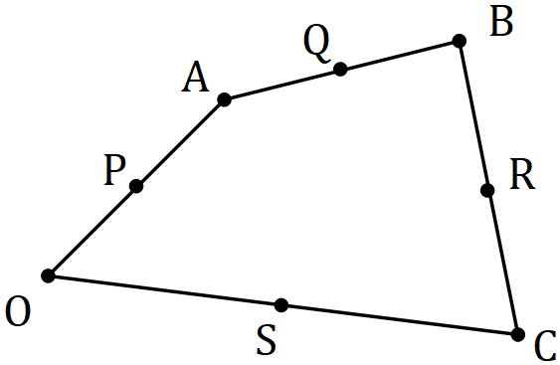

Show that $\vec{PQ}=\vec{SR}$. (4 marks)

|  |
| --- |
| **Solution** |
| $$\vec{PQ}=a+b$$ $$\vec{OR}=2a+2b+\frac{1}{2}\vec{BC} \\ =2a+2b+\frac{1}{2}\left(-2a-2b+2c\right) \\ =a+b+c$$ $$\vec{SR}=\vec{OR}-\vec{OS} \\ =a+b+c-c \\ =a+b \\ =\vec{PQ}$$ |
| **Specific behaviours** |
| ✓ vector  ✓ vector  ✓ vector  ✓ vector $\vec{SR}$ |

Question 20 (6 marks)

The diagram shows a semi-circle, with diameter $SR$ and centre $O$, circumscribed by triangle $ABC$, in which $∠BAC=48°$ and $∠BCA=36°$.

Determine, with reasons, the size of angles $∠PRO$ and $∠PQR$.

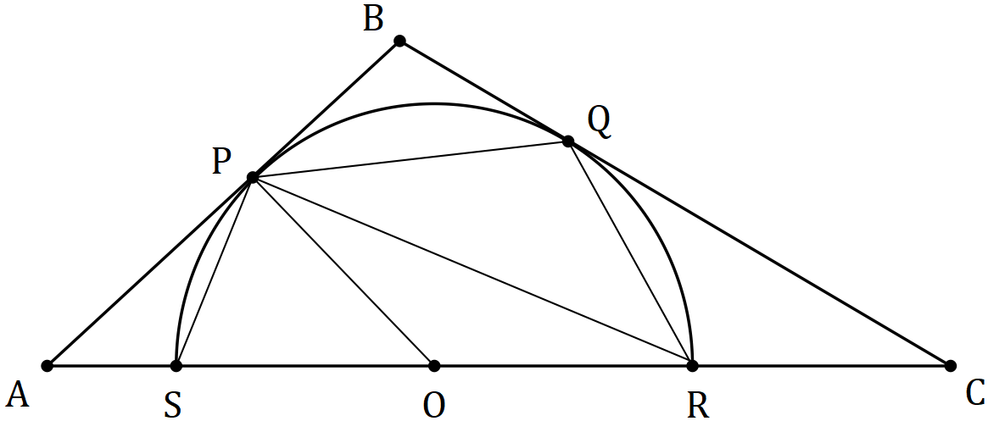

|  |
| --- |
| **Solution** |
| $$∠AOP=90-48=42° (∠APO=90°, \text{tangent-radius})$$ $$∠PRO=42÷2=21° (\text{centre ∠=2×circumference ∠})$$ $$∠PSR=90-21=69° (\text{as }∠SPR=90°, \text{angle in semi-circle})$$ $$∠PQR=180-69=111° (PQRS \text{cyclic quadrilateral})$$ |
| **Specific behaviours** |
| ✓  ✓  ✓ reasoning  ✓  ✓  ✓ reasoning |

Question 21 (8 marks)

The sum of the first $n$ terms of the sequence $1+11+21+…+(10n-9)$ is $n(5n-4)$.

(a) Show that this statement is true when $n=4$. (2 marks)

|  |
| --- |
| **Solution** |
| $$LHS=1+11+21+31=64$$ $$RHS=4\left(5\left(4\right)-4\right)=4×16=64$$ $$\text{Hence statement true}$$ |
| **Specific behaviours** |
| ✓ shows sum of terms for LHS  ✓ shows substitution in RHS and states true |

(b) Use mathematical induction to prove the statement is true for $n∈Z , n≥4$. (6 marks)

|  |
| --- |
| **Solution** |
| $\text{Assume statement true when} n=k$: $$1+11+21+…+\left(10k-9\right)=k(5k-4)$$ $\text{When} n=k+1$: $$1+11+21+…+\left(10k-9\right)+\left(10k-9+10\right)=k\left(5k-4\right)+\left(10k-9+10\right) \\ =5k^{2}+6k+1 \\ =\left(k+1\right)\left(5k+1\right) \\ =\left(k+1\right)\left(5\left(k+1\right)-4\right) \\ =n\left(5n-4\right)\text{ when} n=k+1$$ $$\text{The statement is true for }n=4 \text{ and by induction,}$$ $$\text{the truth when }n=k \text{implies the truth when }n=k+1$$ $$\text{and hence the statement is true for }n≥4.$$ |
| **Specific behaviours** |
| ✓ assumed true for  ✓ adds next term to both sides  ✓ simplifies RHS  ✓ factors k $+1$ out of RHS  ✓ indicates true for  ✓ summary statement including truth of $n=4$ |

Additional working space

Question number: _________

Additional working space

Question number: _________

© 2017 WA Exam Papers. John Curtin College of the Arts has a non-exclusive licence to copy and communicate this document for non-commercial, educational use within the school. No other copying, communication or use is permitted without the express written permission of WA Exam Papers. SN041-101-4.